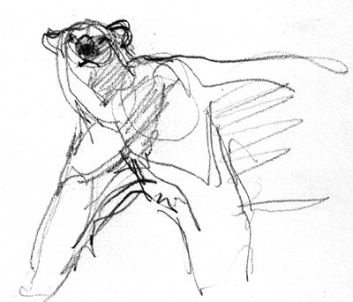
HONORS CHEMISTRY SYLLABUS

Welcome to Chemistry! I would like to share some important information so that this will be a positive year for everyone.

Teacher: Mrs. Jackson, email: kristinejackson@hasd.org
Mr. Schweitzer, email andrewschweitzer@hasd.org

Textbooks: Holt, Rinehart,and Winston, Modern Chemistry (This book is available upon request.)

Course Description: This course will focus on the study matter, its composition, and changes in its composition. This course’s five goals are to help students: develop an understanding of Chemistry, cultivate problem-solving and critical-thinking skills related to Chemistry, apply chemistry knowledge to decision-making about scientific and technological issues, recognize the importance of chemistry in daily life, and understand benefits as well as limitations of science and technology. Chemistry is an incredible avenue for all these types of exploration.
NOTE: This course is designed for students who plan on postsecondary education in medical, engineering and other science fields.

Materials: You must bring these things with you everyday
Calculator: It does not need to be a graphing calculator.
Student passbook
Pencil/Pen

Behavior:
I am giving you the benefit of the doubt. I think you are going to like it here and want to participate. I also believe that every student can give frequent, meaningful and constructive contributions. Here are some examples of what I consider appropriate behavior:
- Using appropriate language and listening. Be a good listener when others are talking. Use positive language!! (no foul language, derogatory or racial comments, inappropriate or disrespectful behavior)
- Participating in labs, class activities, videos, and class discussions.
- Following lab safety rules (such as wearing goggles).
- Displaying proper use of class work time. (no texting or using phones unless asked to do so. If I see your phone…I will collect it.)
- Working in a group setting.
- Cleaning your lab station and glassware. All materials should be cleaned and returned to the original set up.
- Staying in seat until excused. (No “lining up” by the door.)
- Do Not Cheat! Cheating will result in a minor/major referral.

Behavioral Standards: We will be focusing on the following behavioral standards this year in this class:
UNITED: A. S1: Students will communicate and collaborate with others to accomplish tasks and develop solutions to problems and opportunities.
A.S1.a. Learning Target: I can effectively work collaboratively with others.

RESPECTFUL: B. S1: Students will identify and apply employability skills.
B.S1.a. Learning Target: I can identify and demonstrate positive work behaviors and personal qualities needed to be employable.

Labs:
Laboratory policy: INAPPROPRIATE BEHAVIOR IN THE LABORATORY IS VERY DANGEROUS. IF THIS HAPPENS, NO WARNINGS WILL BE GIVEN. YOU WILL BE ASKED TO SIT DOWN AND YOU WILL LOSE ALL POINTS FOR THAT LAB AND FURTHER DISCIPLINARY ACTION WILL BE TAKEN AS NECESSARY. THIS IS A ZERO TOLERANCE ZONE.

Attendance:
Attending class is vital to your success. Be here every day! If you know you will be absent, make plans and inform me ahead of time. This is important!! If you are going to miss class due to athletics, a field trip for another class, a guest speaker, Be Prepared and Be Responsible!

Standards Based Grading: 4 point scale: *see initial SBG letter sent to you via Skyward for more details.
Proficiency Scale Criteria for Reference:
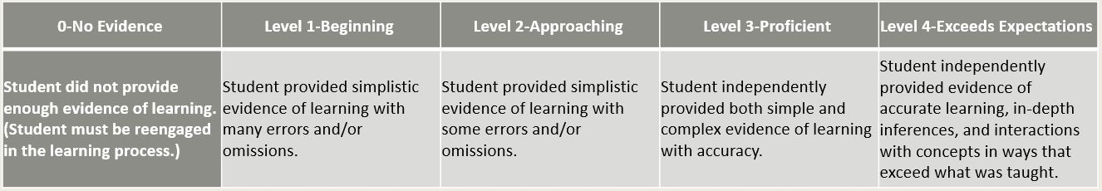

Your grade for the learning target will be an average of all evidence collected. You may re-take any piece of evidence (event) after submitting a remediation ticket. A retake will not initiate a new event, it will replace the old event.
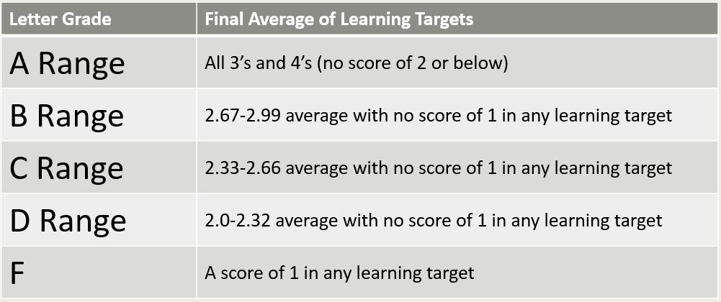
Grade Conversion Chart

* +/- determination will be based on the final exam and at teacher discretion.
Grading:
Your grade is based on quiz assessments, unit assessments and labs.
Assessments:
- Assessments of events with in a learning target will be averaged.
- A reassessment will not initiate a new event, it will replace the old event.

Labs: due on the 3rd school day after completion of lab.
- Science Late Work Policy: If any work is turned in past the due date, student is expected to talk to teacher to explain why the work was not turned in and determine the time frame and process when it will be turned in. All work that is scored must be completed to pass the class. If a student habitually turns in assignments late, there will be a conference with student and contact with parents/guardian to bring awareness and find solution(s) to the issue.
- Labs not returned in to Turnitin.com will be referred to administration.

Role of Semester Finals: Every course will have a meaningful learning opportunity during the final exam period. Students are required to attend for the entire period. Finals will be utilized to determine a holistic performance of course learning targets. Performance on the final may result in a +/- at teacher discretion, or the grade may remain the same.

Communication with parents/guardians: If a student is currently failing or has not submitted appropriate evidence of learning, the teacher will contact the parents upon teacher concern.

